PUBLIC UTILITIES COMMISSION OF THE STATE OF CALIFORNIA

Telecommunications Division | RESOLUTION T-16558
Public Programs Branch | August 23, 2001

R E S O L U T I O N

RESOLUTION T-16558. TO ADOPT THE BUDGET AND SURCHARGE FOR THE FISCAL PERIOD FROM JULY 1, 2002 THROUGH JUNE 30, 2003 FOR THE PUBLIC POLICY PAYPHONE PROGRAM (PPPP).

BY LETTER SUBMITTED MAY 30, 2001 FROM THE PAYPHONE SERVICE PROVIDERS ENFORCEMENT (PSPE) COMMITTEE
_________________________________________________________________

SUMMARY

This resolution adopts the requested budget of $132,899 and reduces the current surcharge rate of $0.08 to $0.00 effective July 1, 2002. A description of the budget is set forth in Appendix B.

BACKGROUND

Decision 98-11-029, dated November 5, 1998, adopted policies and procedures for the PPPP. The PPPP provides payphones to the general public in the interest of public health, safety, and welfare at no charge at locations where there would otherwise not be a payphone. Public policy payphones are placed at locations designated as emergency gathering places or locations where residents cannot individually subscribe to telephone service because of unavailability of facilities. Another requirement is that there must be no other payphone located within 50 yards of the public policy payphone.

The Federal Communications Commission (FCC) deregulated payphones effective April 15, 1997. According to the FCC, this step was designed to promote competition among Payphone Service Providers (PSPs) and to encourage widespread deployment of payphone services to the benefit of the general public, as required by Section 276 of the Telecommunications Act of 1996. The terms and conditions of this deregulation action are set forth in the FCC’s final rules in its investigation into Pay Telephone Reclassification and Compensation Provisions of the Act (FCC Docket No. 96-128, as adopted and released on September 20, 1996, and published in the October 7, 1996 Federal Register Volume 61, pages 52307 through 52325).

The FCC, consistent with Section 276(b)(2) of the Act, considered whether public policy payphones should be maintained and, if so, how to ensure that such payphones are supported fairly and equitably. The FCC concluded that there is a need to ensure the maintenance of public policy payphones in locations where, as a result of competition and the elimination of subsides which helped to support such payphones in the past, there might not otherwise be a payphone. Although the FCC adopted specific guidelines to ensure that these payphones are funded fairly and equitably, it left the primary responsibility for administering and funding such payphones to the individual states.

The FCC, in furtherance of its statutory responsibility under Section 276(b)(2) of the Act, requires each state to review whether the state has adequately provided for public policy payphones in a manner consistent with FCC Docket No. 96-128. It also requires each state to evaluate whether it needs to take any measures to ensure that payphones serving important public interests will continue to exist in light of the elimination of subsides and other competitive provisions, pursuant to Section 276 of the Act.

California has had a public policy payphone program in place since 1990, pursuant to Decision (D.) 90-06-018 (36 CPUC 2d 446 at 461 (1990)). However, this program existed only in the service territories of Pacific Bell and GTE California Incorporated (GTEC). D. 98-11-029 expanded the public policy program statewide. On September 21, 2000, in Resolution T-16404, the Commission adopted the fiscal year budget for the year beginning on July 1, 2001 through June 30, 2002. This Resolution required the Telecommunications Division (TD) to arrange for a program audit of the PPPP to assure the Commission that the program is fulfilling the original objectives set forth in D. 98-11-029. The audit is due on January 2, 2002.

There is no separate committee to perform administrative tasks for the PPPP; the PSPE Committee has the responsibility for all administrative tasks, including the submission of budgets to the Commission.

BUDGET FILING PROCESS

Senate Bill (SB) 669 did not expressly include the PPPP in its statutory provisions although the other two public payphone programs were included. The Commission in Resolution T-16444 adopted a six-month budget for the PPPP to transition to the state budget process on a fiscal year basis. The Telecommunications Division (TD) recommends that the provisions of P.U. Code Sections (Section) 270, 273, 274 and 279 should be applicable to PPPP. TD has incorporated the PPPP into the following sections to show what would take place if the PPPP were included in SB 669.

To comply with the requirements of P.U. Code Section 273 (a), the PSPE Committee must submit a proposed budget through a letter request to the Commission on or before June 1. The Commission has ninety (90) calendar days to approve the proposed PPPP budget since the Commission must submit a Budget Change Proposal for the PPPP Program to the Department of Finance (DOF) by September 1.

Furthermore, P.U. Code Section 274 includes a provision that requires the Commission to conduct a financial and compliance audit of public programs’ related costs and activities at least once every three years, beginning January 1, 2000. In future years under the provisions of P.U. Code Section 270 (b), if the State budget, which includes the PPPP Program budget expenses, is not adopted by the Legislature and signed by the Governor on or before the beginning of the fiscal year, any PSPE related expenses will not be paid even if the associated expenses are approved by the PSPE Committee.

The PPPP should file a proposed budget on June 1, 2002 for the fiscal year of July 31, 2003 through June 30, 2004.

NOTICE/PROTESTS

On May 30, 2001, the PSPE Committee (Committee) submitted to TD a proposed budget of $132,899 for the fiscal year budget period of July 1, 2002 through June 30, 2003. This filing was publicly noticed on the Commission’s Daily Calendar on July 12, 2001, stating that any responses and/or protests on this filing must be made in writing and received by the Commission within 14 days. TD will incorporate any comments received on a timely basis in this Resolution.

DISCUSSION

The Committee’s request of $132,899 for the fiscal year budget, when compared to the $259,556 budget approved for the 01-02 fiscal year, appears to be extremely low. This estimate is based on PSPE staff’s assumption that the costs to maintain this program require a lower allocation of the PSPE staff than in the past. The Committee concurs with this analysis. The pending results of the program audit should provide valuable information on the management needs of this program.

Regarding personnel, TD has reviewed the PSPE’s request for position and staffing and, finding the request to be reasonable, recommends that the request should be adopted as requested.

After considering the budget needs for the fiscal year budget, the Committee recommended that the current surcharge rate of $0.09 per month per pay telephone line be reduced to $0.08 per pay telephone per month, which staff and the Committee believe should be ample to cover the PPPP expenses. TD disagrees with the Committee because TD’s analysis of the financial position of the program indicates that the reserve balance at the end of fiscal year 2003, without any surcharge revenue, should be $721,740. TD recommends that the surcharge rate be reduced to $0.00 effective July 1, 2002. A description of the estimated expenses and revenues supporting TD’s projection is set forth in Appendix B of this Resolution.

We note that the budget for personnel and other administrative expenses is likely to change because of the need to transition PPPP funds to the State Treasury pursuant to Section 270, which was added by Senate Bill (SB) (Polanco 2000). Once PPPP funds are moved to the State Treasury, we expect that the PPPP program will need to be internalized at the Commission. This internalization of the program may occur in the 2001-2002 fiscal year. We await approval of the 2001-2002 State budget to know the precise impact of internalization on the PPPP budget. If the budget is approved in time, we may amend this resolution to reflect the changes resulting from internalization.

NOTICE OF AVAILABILITY OF CONFORMED RESOLUTION

In the past the Commission has served hard copies of resolutions on carriers and parties on the appropriate service list(s). To be consistent with the Commission’s commitment to utilize the CPUC Internet for distributing Commission orders and information, TD has sent a letter of notice to the parties of record in R 98-05-031 as well as the Local Exchange Carriers (LECs) and the Competitive Local Exchange Carriers (CLECs) informing them of the availability of the draft resolution as well as the conformed resolution, when adopted by the Commission, on the Commission website, www.cpuc.ca.gov. In addition, a hard copy of the draft resolution in this matter was sent to the parties of record in R.98-05-031 on July 24, 2001. TD will incorporate any comments on a timely basis in this resolution. Additionally, a copy of the conformed resolution also will be provided to all parties on the service list of R-98-05-031.

All LECs and CLECs that provide a line for a pay telephone should file an advice letter with associated tariff sheets revising the PPPP surcharge on or before June 15, 2002, consistent with the provisions of General Order No. 96-A. The notice requirement of G. O. 96-A, Section III, G.1 (to furnish competing utility companies, either public or private, with copies of the related tariff sheets), should be waived. The advice letter and tariff sheets should become effective on July 1, 2002.

For administrative efficiency, it is reasonable to allow all LECs and CLECs that collect various public program charges, for Fiscal Year 2002-2003, to file one advice letter, accompanied by associated tariff sheets, revising the surcharge rates in accordance with commission adopted resolutions and/or decisions.

FINDINGS

- SB 669 changes the filing requirements for proposed program budgets and surcharge rates to a fiscal year basis from a calendar year basis.
- The PPPP budget for fiscal year July 1, 2002 through June 30, 2003 of $132,899, as set forth in Column D of Appendix B, is reasonable and should be adopted.
- TD’s recommendation that the PPPP current surcharge rate should be reduced to $0.00 effective July 1, 2002 is reasonable and should be adopted.

- The PPPP positions and salaries as set forth in Appendix A of this resolution are reasonable and should be adopted.

- All LECs and CLECs that provide a line for a pay telephone should file an advice letter with associated tariff sheets revising the PPPP surcharge on or before June 15, 2002, consistent with the provisions of General Order No. 96-A. The notice requirement of G. O. 96-A, Section III, G.1., (to furnish competing utility companies, either public or private, with copies of the related tariff sheets), should be waived. The advice letter and tariff sheets should become effective on July 1, 2002.

- For administrative efficiency, it is reasonable to allow all LECs and CLECs that collect various public program charges, for Fiscal Year 2002-2003, to file one advice letter, accompanied by associated tariff sheets, revising the surcharge rates in accordance with commission adopted resolutions and/or decisions.

- The PPPP should file a budget by June 1, 2002 for the fiscal year period of July 1, 2003 through June 30, 2004.

THEREFORE, IT IS ORDERED that:

- The Public Policy Payphone Program’s (PPPP) budget of $132,899 for the fiscal year beginning July 1, 2002 and ending June 30, 2003 as set forth in Column D of Appendix B is adopted.
- The surcharge rate is reduced to $0.00 effective July 1, 2002.

- The PPPP positions and salaries as set forth in Appendix A are adopted.

- All LECs and CLECs that provide a line for a pay telephone should file an advice letter with associated tariff sheets revising the PPPP surcharge on or before June 15, 2002, consistent with the provisions of General Order No. 96-A. The notice requirement of G. O. 96-A, Section III, G.1., (to furnish competing utility companies, either public or private, with copies of the related tariff sheets), should be waived. The advice letter and tariff sheets should become effective on July 1, 2002.

- For administrative efficiency, it is reasonable to allow all LECs and CLECs that collect various public program charges, for Fiscal Year 2002-2003, to file one advice letter, accompanied by associated tariff sheets, revising the surcharge rates in accordance with commission adopted resolutions and/or decisions.

- The PPPP should file a proposed budget with the Commission on June 1, 2002 for the fiscal year beginning July 1, 2003 through June 30, 2004.

This Resolution is effective today.

I hereby certify that this Resolution was adopted by the Public Utilities Commission at its regular meeting on August 23, 2001. The following Commissioners approved it:

WESLEY M. FRANKLIN

Executive Director

APPENDIX A

The following are the adopted positions, base annual salaries and allocations of annual salaries for the 2002-2003 PPPP fiscal year. As the staff also work on the other two public payphone programs, the chart below shows how their salaries and time are proportionately allocated among the Payphone Service Providers Enforcement (PSPE) program and the TDD Interim Placement Program (TPIC) separate from the PPPP.

Positions | Adopted Annual Salary | Total Salary
Director (1) | $73,856 | $ 7,3861
Analysts (1) | $36,928 | N/A2
Office Assistant (1) | $39,314 | $3,9313
Inspectors (8) | $40,918 | $16,6374
Field Supervisor (1) | $44,023 | $2,2015
 | TOTAL | $29,986

APPENDIX B

PPPP FISCAL YEAR BUDGET YEAR 2002/2003

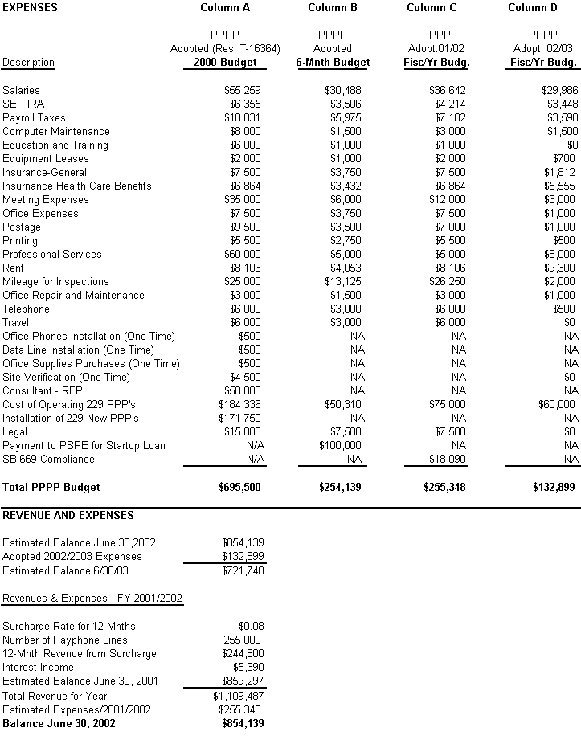

STATE OF CALIFORNIA GRAY DAVIS, Governor
PUBLIC UTILITIES COMMISSION
505 VAN NESS AVENUE
SAN FRANCISCO, CA 94102-3298

July 24, 2001

To: Parties of Record to I. 88-04-029, R.98-05-031, Local Exchange Carriers (LECs) and Competitive Local Exchange Carriers (CLECs)

Enclosed are draft Resolutions T-16557 and T-16558.

Draft Resolution T-16557 proposes approval of the following:

*The Payphone Service Providers Payphone Program budget for July 1, 2002, to June 30, 2003, in the amount of $1,188,787.
*A decrease in the surcharge rate of $0.10 per pay telephone per month to zero effective July 1, 2002.

Draft Resolution T-16558 proposes approval of the following:

*The Public Policy Payphone Program budget for July1, 2002, to June 30, 2003, in the amount of $132,899.
*A decrease in the surcharge rate of $0.09 per month per pay telephone rate to zero effective July 1, 2002.

A copy of this draft resolution is available at the Commission’s web site at cpuc.ca.gov . This Notice of Availability of the draft resolutions also informs you of the availability of the final resolution, when adopted by the Commission, on the same web site. Hard copies of this draft resolution are being mailed to the parties of record to I. 88-04-029 and R. 98-05-031. If you have not received a hard copy or do not have Internet access, you may obtain a copy of this draft resolution by contacting the Telecommunications Division at (415) 703-2117.

Pursuant to Public Utilities (PU) Code 311(g)(1), this draft resolution is available for public comments. Opening comments should be focused on factual, legal, and/or technical errors in the draft resolution. Opening comments should be limited to five pages in length and shall include a subject index listing the recommendations to the draft resolution, a table of authorities, and an appendix setting forth the proposed revised findings and ordering paragraphs. Reply comments shall be limited to identifying misrepresentations of law, fact, or condition of the record contained in the comments of other parties. Replies shall not exceed three pages in length and shall be submitted and served in the same manner as opening comments.

Opening comments on these draft resolutions must be submitted on or before August 14, 2001 (which is 15 days from the date of this mailing). Reply comments may be submitted on or before August 20, 2001 (five days after opening comments are submitted). Opening comments and/or reply comments should be addressed to:

California Public Utilities Commission
Attn: MJ Purcell
Telecommunications Division
505 Van Ness Avenue, 3rd Floor
San Francisco, CA 94102

The date of submission is the date that the Telecommunications Division receives opening comments or reply comments. Parties must serve a copy of their opening comments and/or reply comments on each party set forth on the service list attached to the draft resolution, on the same date that the opening comments and/or reply comments are submitted to the Telecommunications Division.

Late-filed opening comments and/or reply comments will ordinarily be rejected. However, in extraordinary circumstances, a request for leave to submit opening comments or replies late may be filed together with proposed comments/replies. An accompanying declaration under penalty or perjury shall be submitted setting forth all the reasons for the late submission.

This draft resolution will be on the agenda of the Commission’s August 23, 2001 meeting. The Commission may vote on the draft resolution on this date, or postpone a vote until later. When the Commission votes, it may adopt the resolution as drafted, or it may amend, modify, or set aside the resolution and prepare a different resolution. Only when the Commission acts does the resolution become binding on the parties.

Sincerely,

/s/ JOHN M. LEUTZA
John M. Leutza, Director
Telecommunications Division

Enclosure (Draft Resolution T-16557 with service list for the parties of record to
I. 88-04-029. Draft Resolution T-16558 with service list for the parties of record to R-98-05-031.)

1T he adopted salary for the Program Director is $73,856. 70% ($51,700) is allocated to the PSPE fiscal Yr Budget, 20% ($14,771 is allocated to the TPIC Fiscal Yr. Budget, and 10% ($7,386) is allocated to the PPPC Fiscal Yr. Month budget.
2 There are four (4) Analysts in the PSPE Program office. They work full time for the PSPE program.
3 There is one Office Assistant. The salary is allocated 80% to PSPE ($30,787) and allocated 10% ($3848) each to TPIC and PPPP.
4 There are 8 inspectors. The salary and time are allocated 85% ($34,000 x 8) to PSPE. For TPIC 10% (31,208) allocated and for PPPP 5% ($2000 x 8) is allocated.
5 There is one field supervisor. The salary is allocated 75% ($33,017) to PSPE, 20% ($8804) to TPIC and 5% ($2157) to PPPP.

